Chef Jean-Luc Boulay, Maître Cuisinier de France, and his brigade wish to send your taste buds on a journey with our seven-course Discovery Menu at $155, inspired by local Quebec products.
(Ask your waiter, different wine pairing available on request.)

SPRING MENU 2023

APPETISERS

Foie gras terrine
Sea Buckthorn jelly, fruits coulis
Local candied berries and toasted house made brioche 29.

The foie gras Experience
Five ways of tradition and innovation
Variations of textured fruits and vegetables 39.

Seared foie gras
Cake renversé with wild strawberries
Thyme tiles and duck jus 39.

Bison
Lightly torched marinated loin with boreal seasoning
Pickled crosne and red cabbage purée
Élizabeth blue cheese sauce and spiced red wine syrup 29.

Arctic char
Arctic char longuet, marinated mushrooms
Glasswort
Fennel purée, herbs sauce 29.

Snow Crab and Caviar
Glasswort crips and Granny-Smith apple rope
Crab milk and sweetgrass oil 35.

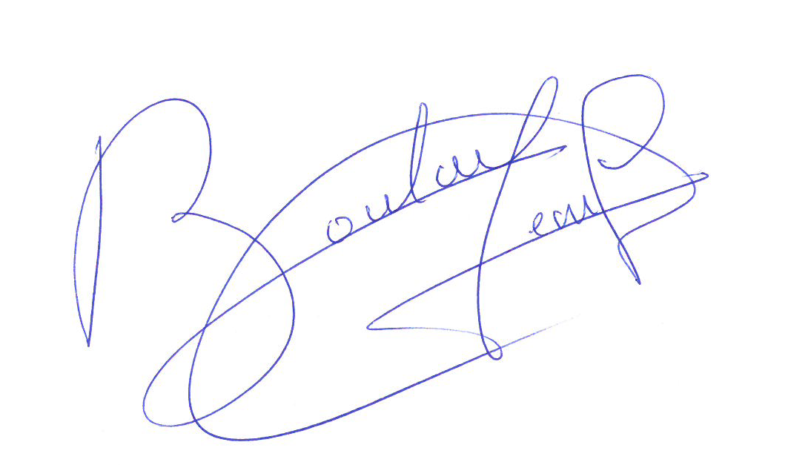

MAIN COURSES

Squab
breast stuffed with Lardo di Colonnata
Beets, Candied rhubarb, black walnut
Vegetable jus 66.

Duck supreme
Cromesquis with peach and foie gras
Savory carrot cake, duck heart
Black spruce sauce 56.

Veal sweetbreads and lobster
Morels stuffed with Matane shrimp, asparagus
Lillet Meat jus 56.

Halibut
Leeks, seaweed and smoked almonds
Black garlic from Quebec
Noilly Prat sauce 56.

Lamb
Rack, filet mignon and flanks
Eggplant and plum chutney
Hazelnut And lamb jus 56.

Scallops
Butternut squash purée
Mushroom duxelle, Chestnut mushrooms
Porcini cream sauce 56.

Please, inform us of any food allergies.
The fresh market cuisine experience requires a certain time for preparation.
Thank you for your understanding!

